**Subdomain Finder**

Submitted in partial fulfillment of the requirements for the award of degree of

**BACHELOR OF ENGINEERING**

**IN**

**COMPUTER SCIENCE & ENGINEERING**



**Submitted to:**

**Mentor name: Er. Kulvinder Singh**

**Submitted By:**

**NAME: Azeem Pasha**

**UID: 18BCS1391**

**DEPARTMENT OF COMPUTER SCIENCE & ENGINEERING**

**Chandigarh University, Gharuan**

**Project Design :-**

This report is about the project named “Subdomain Finder”. Subdomain finder basically finds the subdomains that exists in a main domain. Subdomains are like children and domain is like a parent. The prototype I created with responses very fast and accurate.

**Innovation in model/design/solution:**

The s/w uses custom wordlists to brute-force the subdomains. Let’s have a look on the schematic diagram of how it look and works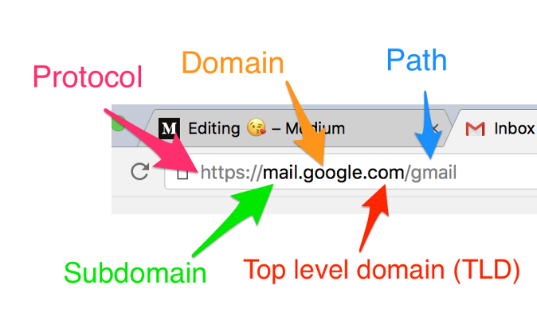

**Bibliography:-**

<https://pythoncode.com/>

https://www.python.org/doc/